**Devvortex walkthrough**

# **Index**

Index 1

List of pictures 1

Disclaimer 2

Reconnaissance 2

Initial foothold 2

User flag 4

Privilege escalation 6

# **List of pictures**

Picture 1 - nMap scan results 2

Picture 2 - Subdomain enumeration 3

Picture 3 - Robots.txt file on dev.devvortex.htb 3

Picture 4 - Databases credentials 4

Picture 5 - Reverse shell command in index.php template page 4

Picture 6 - Reverse shell successful connection 5

Picture 7 - User credentials in dataabse 5

Picture 8 - Password cracked 5

Picture 9 - SSH connection as logan 6

Picture 10 - User flag 6

Picture 11 - Information useful to escalate privileges 6

Picture 12 - /usr/bin/apport-cli command execution 7

Picture 13 - Privilege escalation 7

Picture 14 - Root flag 7

# **Disclaimer**

I do this box to learn things and challenge myself. I’m not a kind of penetration tester guru who always knows where to look for the right answer. Use it as a guide or support. Remember that it is always better to try it by yourself. All data and information provided on my walkthrough are for informational and educational purpose only. The tutorial and demo provided here is only for those who’re willing and curious to know and learn about Ethical Hacking, Security and Penetration Testing.

# **Reconnaissance**

The results of an initial nMap scan are the following:

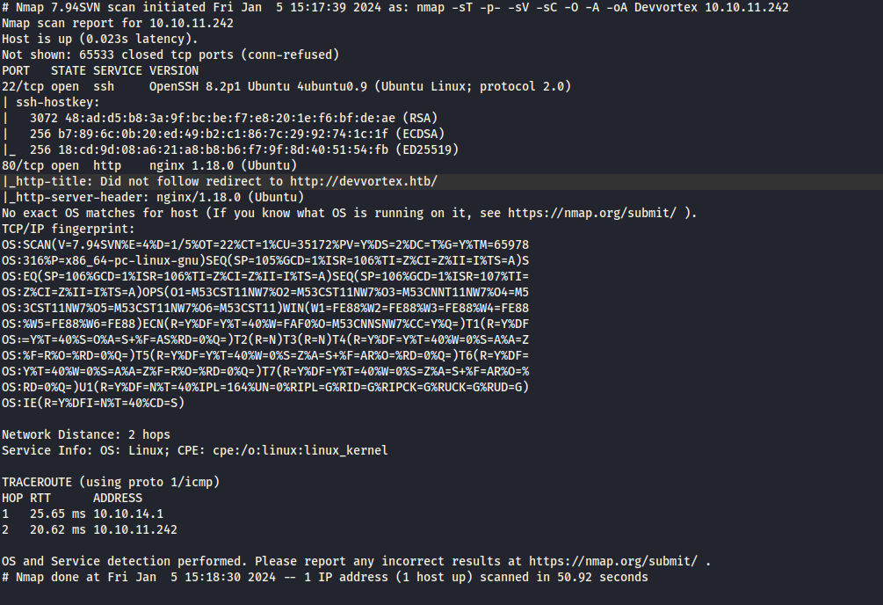

Picture 1 - nMap scan results

Open ports are 22 and 80. So, the machine has SSH enabled and an application running on port 80. NMap detected that operative system is Linux, but didn’t provide any other specific information about it.

# **Initial foothold**

One important step to follow while analyzing a web application, is the subdomain enumeration. In this case, I was able to find a new subdomain as shown in the following picture:

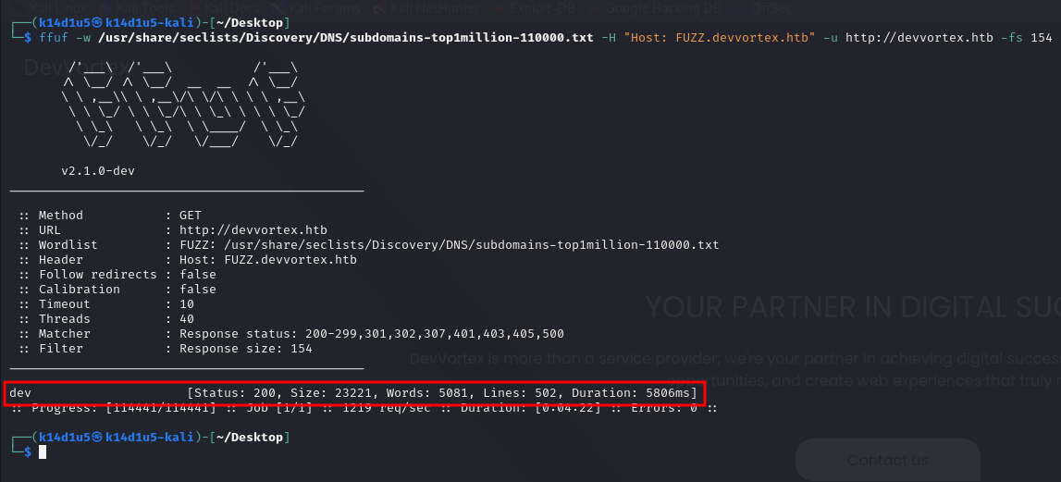

Picture 2 - Subdomain enumeration

So, I started to analyze this new subdomain. Here, ***robot.txt*** is accessible and it provide some useful information. In fact, I found an administrative path:

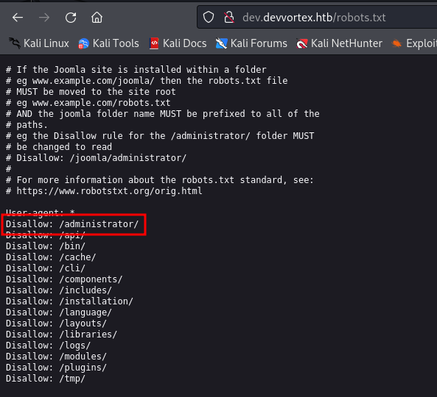

Picture 3 - Robots.txt file on dev.devvortex.htb

I tried to access to that path and I found a Joomla administrator login form. I looked for some known vulnerabilities on the Internet, and I found [**CVE-2023-23752**](https://nvd.nist.gov/vuln/detail/CVE-2023-23752). This CV is about an ***Improper Access Execution*** vulnerability in the ***/api/index.php/v1/config/application***, ***/joomla/api/v1/config/application?public=true***, ***/api/index.php/v1/config/application?public=true***, ***/api/v1/config/application?public=true*** endpoints of the Joomla server. The public parameter of the vulnerable endpoint allows an attacker to access the Joomla-related configuration information which eventually leads to the disclosure of sensitive information such as database username and password.

# **User flag**

Since I found an interesting CVE about Joomla, I tried to run its exploit. It works and it provides me the following information:

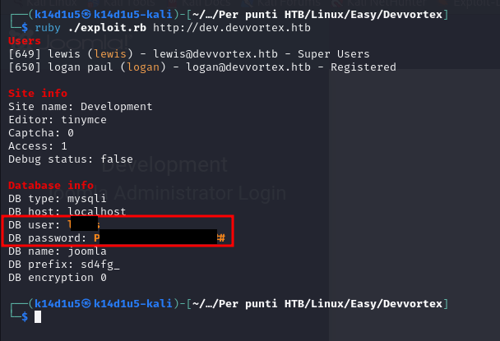

Picture 4 - Databases credentials

I had some credentials at this point, so I tried to use them in the Joomla Administrator login form and they work. In this administrative panel, after a deep inspection, it was possible to modify administrative templates. So, I modified the ***index.php*** page of [***http://devvortex.htb***](http://devvortex.htb) to set up a reverse shell:

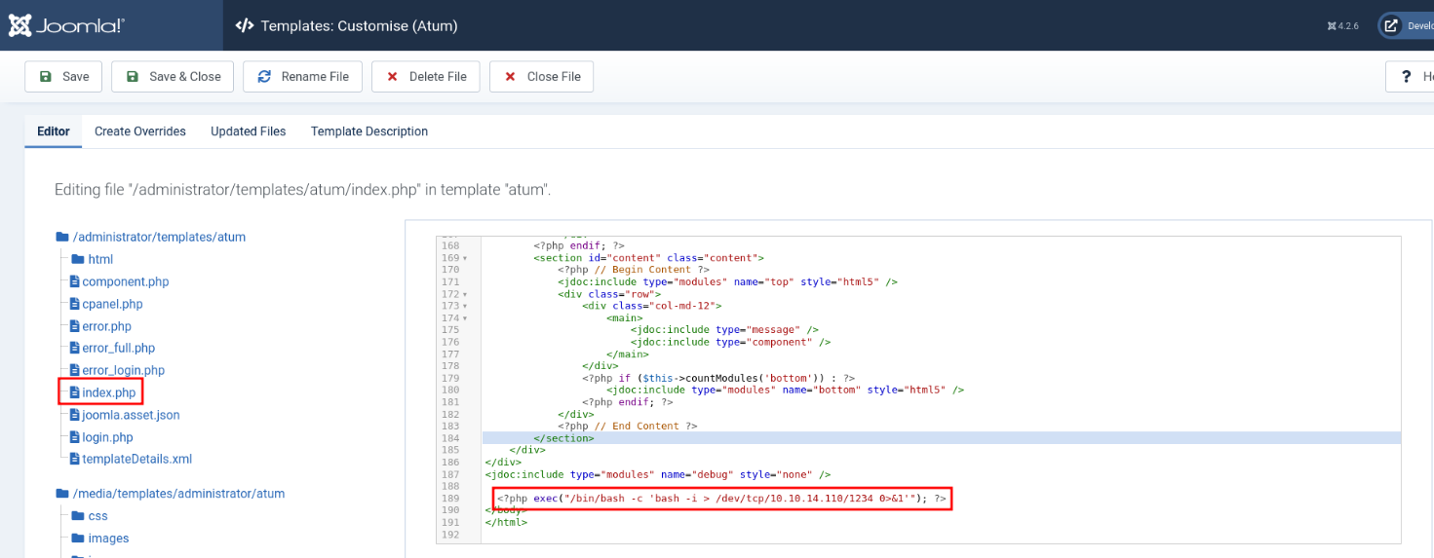

Picture 5 - Reverse shell command in index.php template page

At this point, I had to set a listener to receive the reverse shell and I needed to reload the index page on [***http://devvortex.htb***](http://devvortex.htb). In this way, I obtained a reverse shell with ***www-data*** user:

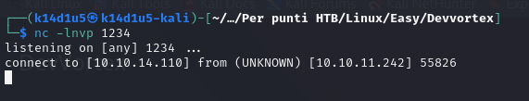

Picture 6 - Reverse shell successful connection

This shell was not good enough to work, so I needed to upgrade and stabilize it with the following steps:

script /dev/null -c /bin/bash

CTRL + Z

stty raw -echo; fg

Then press Enter twice, and then enter:

export TERM=xterm

At this point, I remembered I found databases credential, so I tried to connect with it. It worked and I inspected the database. At the end, I found some user credentials:

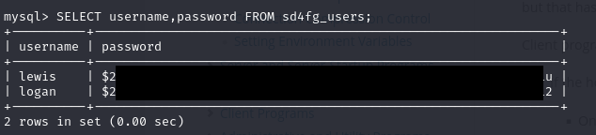

Picture 7 - User credentials in database

I tried to crack this password with ***JohnTheRipper*** tool:

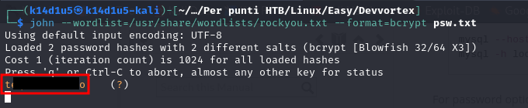

Picture 8 - Password cracked

Luckily, tool cracked one password, the one related to ***logan*** user. So, I connect in SSH with these new credentials:

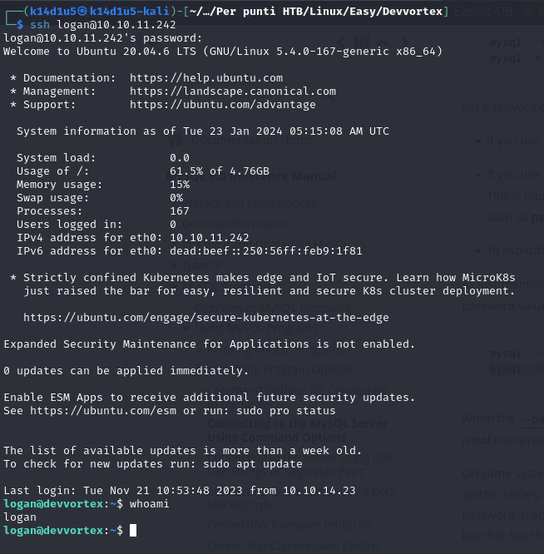

Picture 9 - SSH connection as logan

At this point, I was able to retrieve the user flag:



Picture 10 - User flag

# **Privilege escalation**

In this case, to escalate my privilege, I saw that ***logan*** user was able to run ***/usr/bin/apport-cli*** as ***sudo***:

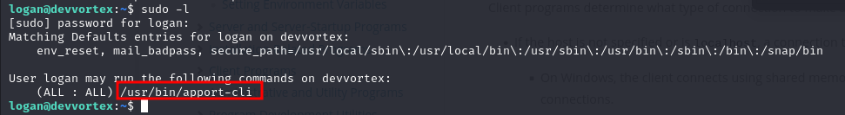

Picture 11 - Information useful to escalate privileges

I run this command and it let me to build a report in a text editor similar to ***vim***:

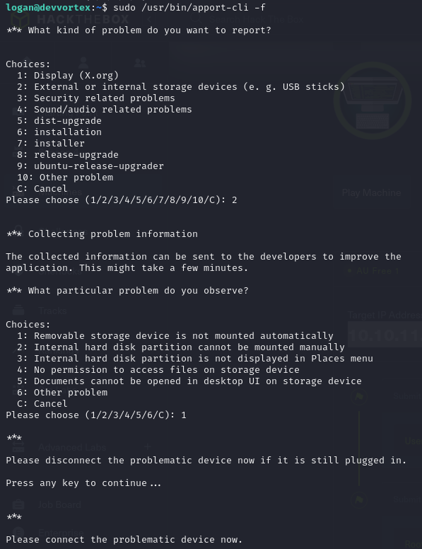

Picture 12 - /usr/bin/apport-cli command execution

So, I re-run this command as ***sudo*** and I exploit it to obtain a root shell. To achieve this goal, I sent a command inside the vim-like text editor opened by the command, in the same way I could in vim. In particular, I sent the command $!/bin/bash$:

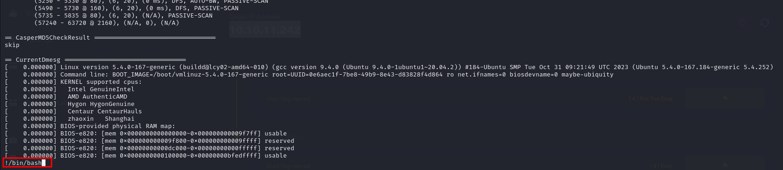

Picture 13 - Privilege escalation

At this point, I had just to retrieve the root flag:

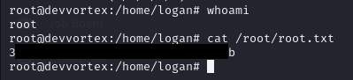

Picture 14 - Root flag